Getting Started.
Mathematica first appeared in 1988. Every iteration since has built upon the previous version, while still being backwards compatible. Mathematica allows fast computation of problems that would take a comparably long time to do by hand.
First Open Wolfram Mathematica, if you are unsure where Mathematica is on your computer, search Mathematica in your windows taskbar.
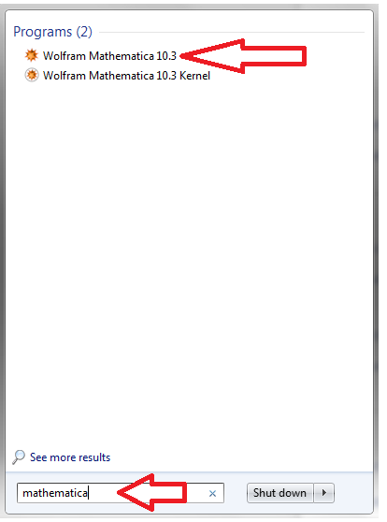

After opening Mathematica, be sure to enable the Classroom Assistant.
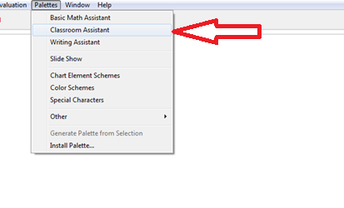
To calculate a derivative, under the third tab in basic commands, hit the D button.
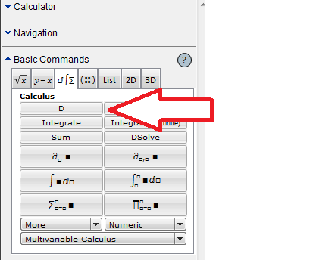
Which makes this appear
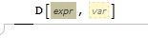

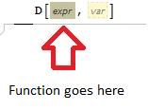
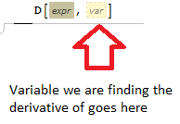
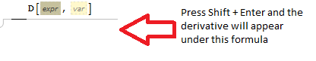
As an example, to find the derivative of $x^{2}$

What is the derivative of: $x^{4}+{7x}^{3}+14$?

What is the derivative of: $x^{4}+{7x}^{3}+14$sin($x^{3}+x)-2$cos($2x^{2}+4x)+\frac{x^{2}}{x-1}$?

Critical Points
Critical Points-where the derivative of a function equals 0 or where the derivative does not exist. This indicates a potential change from increasing or decreasing.
Find the Critical Points of $f\left(x\right)=x^{3}+{2x}^{2}-5x-3$.
To view this as a graph, first put in the equation.
Hit enter then go to the 2D tab of classroom assistant and click Plot.
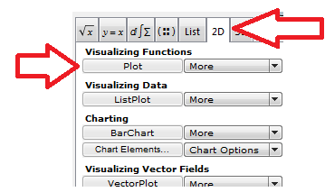
Put in the equation ($f\left(x\right)$), and the minimum and maximum values of a chosen variable to be displayed on the graph.
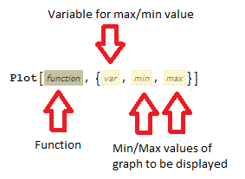

The critical points will be around the points indicated by the red arrows
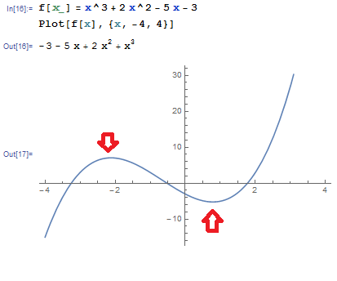
To find the critical point, solve for the derivative
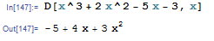

Since this clearly will exist for all $x$. Find where this function is zero. The Solve Command in Classroom Assistant can be helpful.
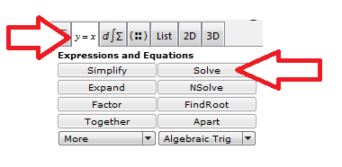

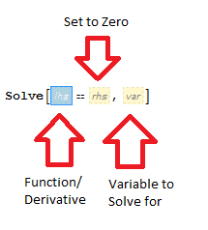
Putting in the derivative:
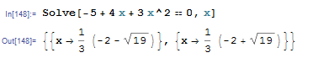
If you use $f[x__] =$ then Mathematica will remember$f[x]$ and you can use:
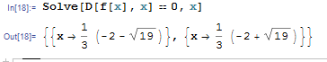

What are the Critical points on $f\left(x\right)=x^{3}+{2x}^{2}-x/3$?

Optimization
Critical Points can be used to find where an equation “changes direction” or when it changes from increasing to decreasing or vice versa. If it goes from increasing to decreasing, then that critical point will be a local maximum. If it goes from decreasing to increasing, then that critical point will be a local maximum.
Example: A cookie production factory can create a maximum of 250 cookies in one day. The production manager is looking to maximize profit. The total daily profit of making $x$ cookies in a day is given by the equation
$$C\left(x\right)={-8x}^{2}+3,200x+80,000$$
How many cookies should be produced to minimize production costs?
A graph of the function looks like the maximum value is around 200. Actually solving for the derivative will confirm this.
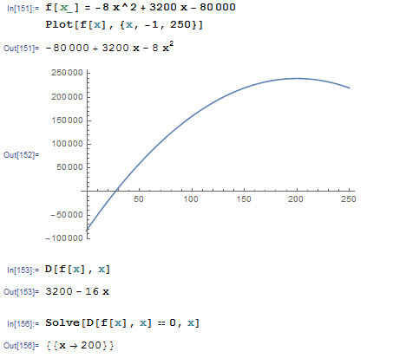
To find the how the profit is changing at 120 cookies. Plug 120 into the derivative equation.
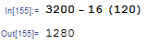

One day the Cookie Monster snuck into the factory and ate a bunch of cookies. This changed the equation to:
$$C\left(x\right)={-8x}^{3}{+504x}^{2}-800$$
How many Cookies should they now produce to obtain the maximum profit?

Position, Velocity, Acceleration

Velocity is the derivative of Position.
Acceleration is the derivative of Velocity.
Finding the Velocity of $f\left(t\right)=t^{5}-11t^{2}+t+($sin$5t)/4-$cos$t$
First a graph of the position function shows. Find the derivative of $\left(t\right)$
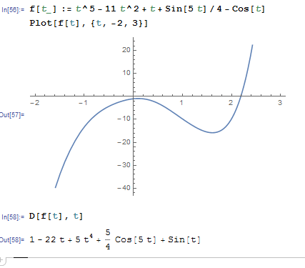

To find the acceleration, find the derivative of the velocity.
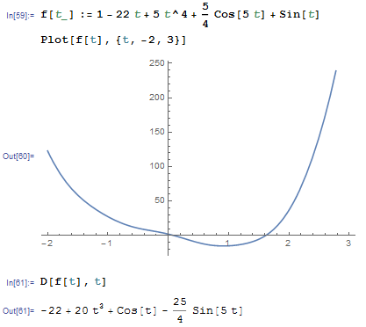
To find the acceleration equation in 1 step
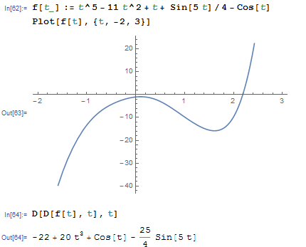

Given the Position Function
$$f\left(t\right)=t^{2}-4t$$
Find the Velocity Function

When does the particle change direction?

What is the acceleration function?

Additional Application: Jerk, Snap (jounce), Crackle, and Pop

Jerk-derivative of acceleration with respect to time
Snap (jounce )-derivative of Jerk with respect to time
Crackle -derivative of Snap (jounce) with respect to time
Pop -derivative of Crackle with respect to time

