2D and 3D Maze Solving Algorithms

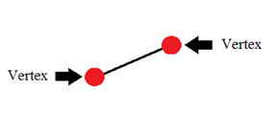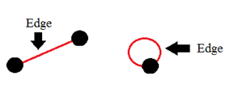
Representing a Maze as a Graph
Vertex: Intersections of 3 or more paths, Dead Ends, Start, and Finish
Edge: Paths between vertices
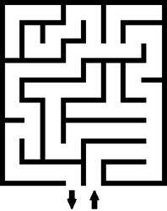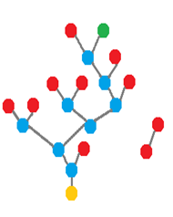

Maze Solving Algorithms

Wall Following
-Follow the left or right wall from the start.
-Works if the start and end of the maze are in at the edge of the maze.
-Will only work if the start or end has a wall connecting them.
Trémaux's Algorithm
-Mark a path once you follow it. Never go down a path with 2 marks.
-At each intersection, choose an arbitrary path with the fewest marks.
-Turn around at dead ends.
Dead End Filling
-Fill in all the dead ends and gradually connect the filled in dead ends until a path to the
end is revealed.
Breadth First
-Explore starting point’s neighbors.
-Move onto next level until the end is reached.
-Each vertex appears only as the first connection.
Wall Following
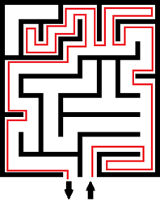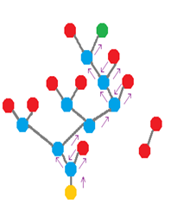

Trémaux's Algorithm 3D Maze as a 2D Maze
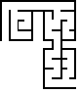

Weighted Paths
